UPES PYTHON LAB ASSIGNMENT

***EXPERIMENT = 9***

***NAME = ANMOL YADAV***

***BATCH = B8***

***SAP ID = 500083814***

*QUESTION:-*

Q1. Input two values from user where the first line contains N, the number of test cases.  
The next N lines contain the space separated values of a and b. Perform integer division and print a/b. Print the error code in the case of ZeroDivisionError or ValueError.

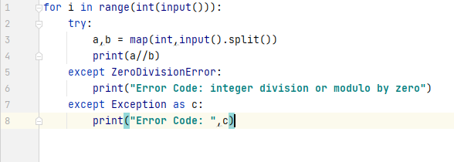

OUTPUT:-

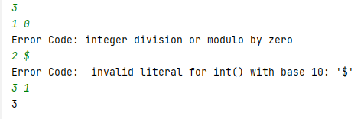

Q2. Assume the following Python code-

Rewrite the code to handle the exceptions raised. Print appropriate error messages wherever applicable.

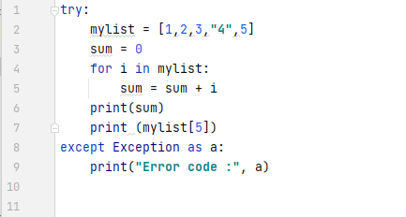

OUTPUT:-

